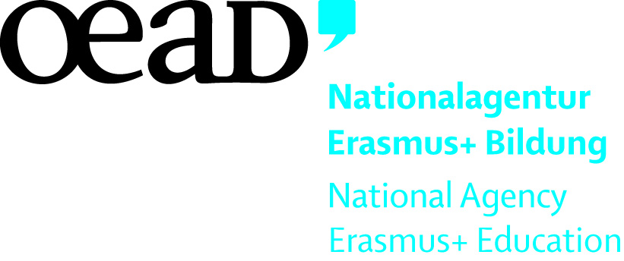

Rates applicable for unit contributions

Key Action 1 – Learning Mobility

1. Travel – Contribution to the travel costs

Travel distances | Amount
Between 10 and 99 KM: | 20 EUR per participant
Between 100 and 499 KM: | 180 EUR per participant
Between 500 and 1999 KM: | 275 EUR per participant
Between 2000 and 2999 KM: | 360 EUR per participant
Between 3000 and 3999 KM: | 530 EUR per participant
Between 4000 and 7999 KM: | 820 EUR per participant
8000 KM or more: | 1500 EUR per participant

Nota bene: the "travel distance" represents the distance between the place of origin and the venue, whereas the "amount" covers the contribution to the travel both to and from the venue.

2. Individual support

Staff mobility from Partner to Programme Countries

 | Staff from Partner Countries
Receiving country | Amount per day in EUR
Norway, Denmark, Luxembourg, United Kingdom, Iceland, Sweden, Ireland, Finland, Liechtenstein | 180
Netherlands, Austria, Belgium, France, Germany, Italy, Spain, Cyprus, Greece, Malta, Portugal | 160
Slovenia, Estonia, Latvia, Croatia, Slovakia, Czech Republic, Lithuania, Turkey, Hungary, Poland, Romania, Bulgaria, North Macedonia, Serbia | 140

Nota bene: the amount per day is calculated as follows:
up to the 14th day of activity: the amount per day per participant as specified in the table above
+
between the 15 th and 60 th day of activity: 70% of amount per day per participant as specified in the table above

Staff mobility from Programme to Partner Countries

Amount per day in EUR | 180

Nota bene: the amount per day is calculated as follows:
up to the 14th day of activity: the amount per day per participant as specified in the table above
+
between the 15 th and 60 th day of activity: 70% of amount per day per participant as specified in the table above

HE student mobility between Programme and Partner Countries

From | To | Amount
Eligible Partner Countries | Group 1 Programme Countries | 900 EUR per month
 | Group 2 Programme Countries | 850 EUR per month
 | Group 3 Programme Countries | 800 EUR per month
Programme Countries | Partner Countries | 700 EUR per month

3. Organisational support

350 EUR per participant

